EXPERIMENT 7
Title
Integration of Dashboard, Scorecard Development and Advanced Analytics with Business Intelligence Reports using Microsoft Power BI
1. Aim
To develop interactive dashboards and business scorecards using Microsoft Power BI, integrate advanced analytics into Business Intelligence reports, analyze organizational performance, identify business strengths, weaknesses and opportunities, and generate data-driven recommendations to support strategic decision-making.
2. Software Requirements
- Microsoft Power BI Desktop
- Global Superstore Dataset.xlsx
- Power Query Editor
- Microsoft PowerPoint
3. Dataset Source
Global Superstore Dataset – Kaggle
https://www.kaggle.com/datasets/apoorvaappz/global-super-store-dataset
4. Theory
Business Intelligence (BI) transforms raw business data into meaningful information that supports organizational decision-making. Microsoft Power BI provides interactive visualizations, dashboards, reports, KPIs and analytical tools for monitoring business performance.
Dashboard development involves presenting important business indicators such as total sales, total profit, total orders and profit margin. A business scorecard compares actual performance against predefined targets and helps management evaluate whether organizational objectives are being achieved.
Relational and multidimensional reporting enables users to examine business information at different levels of detail. OLAP operations such as Slice, Dice, Drill-Down and Drill-Up provide different perspectives of the same dataset.
Advanced analytics extends traditional BI reporting by identifying trends, comparing performance, evaluating profitability, analyzing customer segments and discovering business opportunities. Geographic, product, customer and time-based analysis helps organizations understand performance differences and identify areas requiring improvement.
By combining dashboards, scorecards and advanced analytical reports, organizations can convert business data into actionable insights and strategic recommendations.
5. Implementation / Procedure
A. Data Preparation and OLAP Analysis
The Global Superstore dataset was imported into Power BI Desktop using Power Query Editor. Data types, columns and relationships were verified before loading the dataset.
Slice and Dice operations were performed using Region, Category and Year filters. Drill-Down and Drill-Up operations were applied through the geographical hierarchy Region → State → City to analyze information at different levels of detail.
B. Relational and Multidimensional Reporting
A Relational Report was developed using a Table visual containing Order ID, Customer Name, Product Name, Region, Sales and Profit.
A Matrix Report was created using geographical hierarchy and measures such as Total Sales, Total Profit and Quantity. Comparative Analysis was performed using Sales by Category, Profit by Region, Top 10 Customers by Sales and Sales Trend by Year.
C. Interactive Dashboard Development
An interactive dashboard was developed using KPI cards, charts and slicers. The main indicators included Total Sales, Total Profit, Total Orders and Quantity.
Visualizations were created to display Sales by Category, Profit by Region and Sales Trend by Year. Slicers for Region, Category and Year were added to enable dynamic filtering.
D. Executive Dashboard Development
An Executive Dashboard was created to provide an overview of organizational performance. KPI cards were developed for Total Sales, Total Profit, Total Orders and Profit Margin.
Additional visualizations included Sales by Region, Sales by Category, Monthly Sales Trend, Top 10 Customers by Sales and Profit by Segment. Interactive slicers were incorporated to support detailed analysis.
E. Business Scorecard Development
A Business Scorecard was developed to compare actual performance with predefined targets.
The scorecard included:
- Total Sales, Sales Target, Sales Achievement (%) and Sales Status.
- Total Profit, Profit Target, Profit Achievement (%) and Profit Status.
- Total Orders, Order Target, Orders Achievement (%) and Orders Status.
Achievement percentages were calculated by dividing actual performance by the corresponding target. Conditional formatting was applied to distinguish achieved, partially achieved and not achieved performance.
F. Geographic Analysis
A Geographic Analysis report was designed to examine sales and profitability across different geographical areas.
Map or Azure Maps visualizations were considered for displaying sales by State or City. Regional bar charts and geographical tables were also used to compare Total Sales and Total Profit. A Region slicer was incorporated for interactive analysis.
G. Product Performance Analysis
Product performance was analyzed using Category and Sub-Category information.
Bar charts were created to compare sales and profitability across product categories. A Treemap was used to display sales distribution, while a Scatter chart was used to examine the relationship between Sales and Profit.
Top 5 Profitable Sub-Categories and Bottom 5 Sub-Categories by Profit were identified using visual-level Top N filters.
H. Customer Segment Analysis
Customer performance was analyzed across Consumer, Corporate and Home Office segments.
Donut charts, bar charts and tables were used to compare sales, profit and orders across customer segments. A Top 10 Customers visual was also created based on Total Sales.
I. Monthly and Yearly Sales Trend Analysis
Time-based analysis was performed using the Order Date field.
Line charts were created to display monthly Sales and Profit trends, while column charts were used to compare yearly Sales and Profit. A Year slicer was added to support interactive analysis.
J. Advanced Business Insights
A Business Insights page was developed to summarize the analytical findings.
KPI visuals were used to display Sales Growth (%) and Profit Margin (%). Bar charts displayed the Top 5 Profitable and Bottom 5 Sub-Categories by Profit.
A Business Issues and Recommendations table was prepared with three columns: Business Issue, Evidence and Recommendation. Separate sections were included to present Business Strengths, Business Weaknesses and Opportunities for Improvement.
K. Business Insight Report and Executive Presentation
A Business Insight Report was prepared to document the objective, dashboards used, key findings, strengths, weaknesses, opportunities, recommendations and conclusion.
An executive presentation of 5–7 slides was structured to communicate the dashboard overview, key findings, business issues and recommendations using Power BI screenshots and analytical evidence.
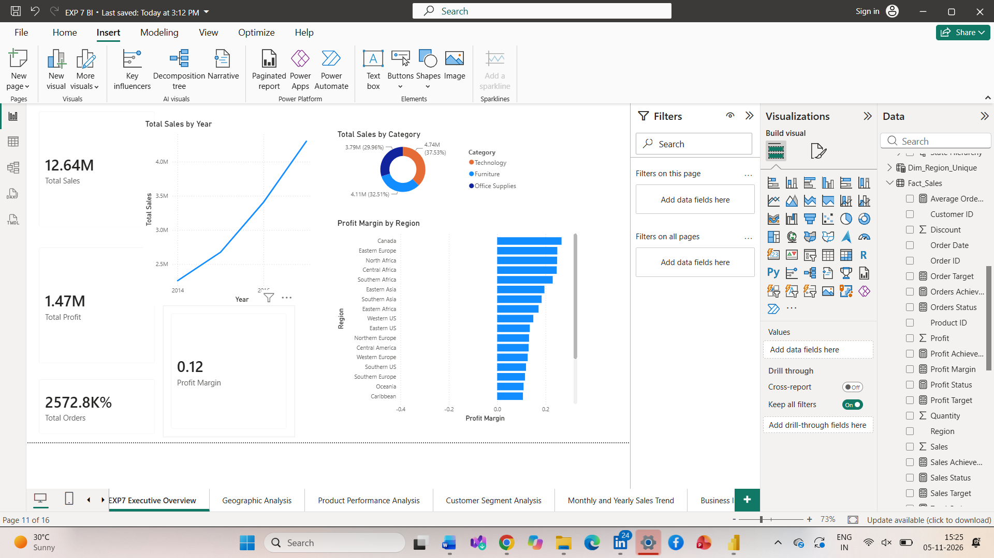
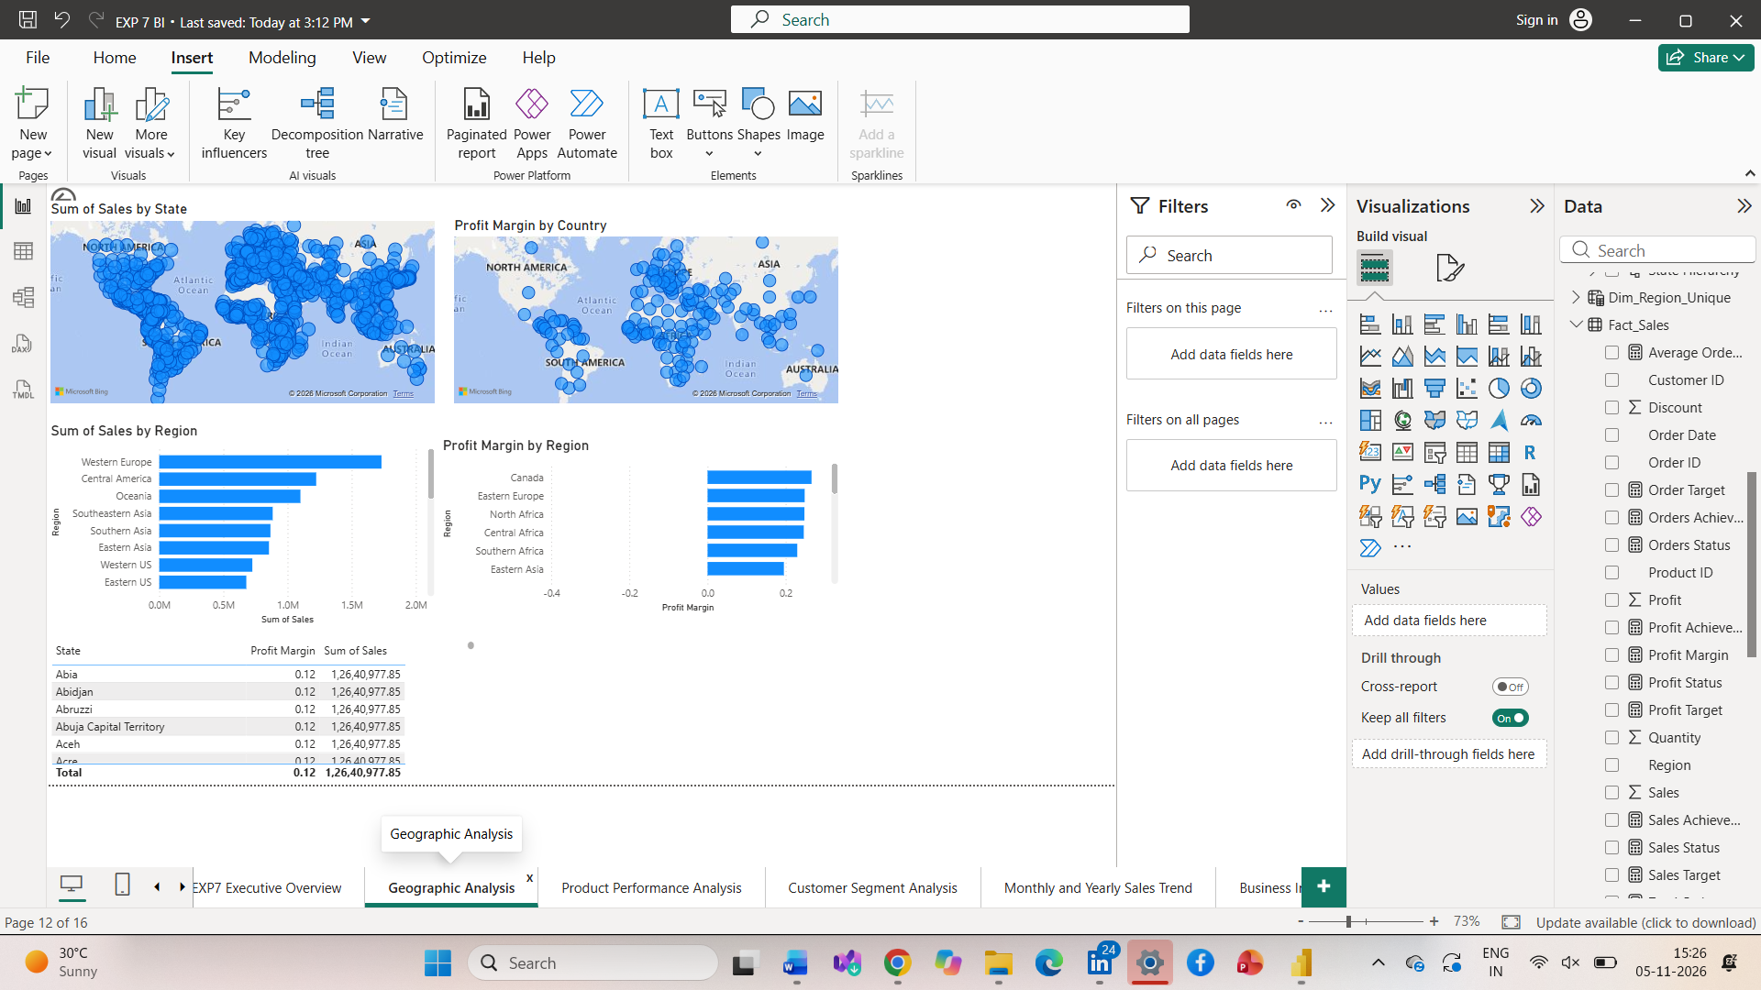
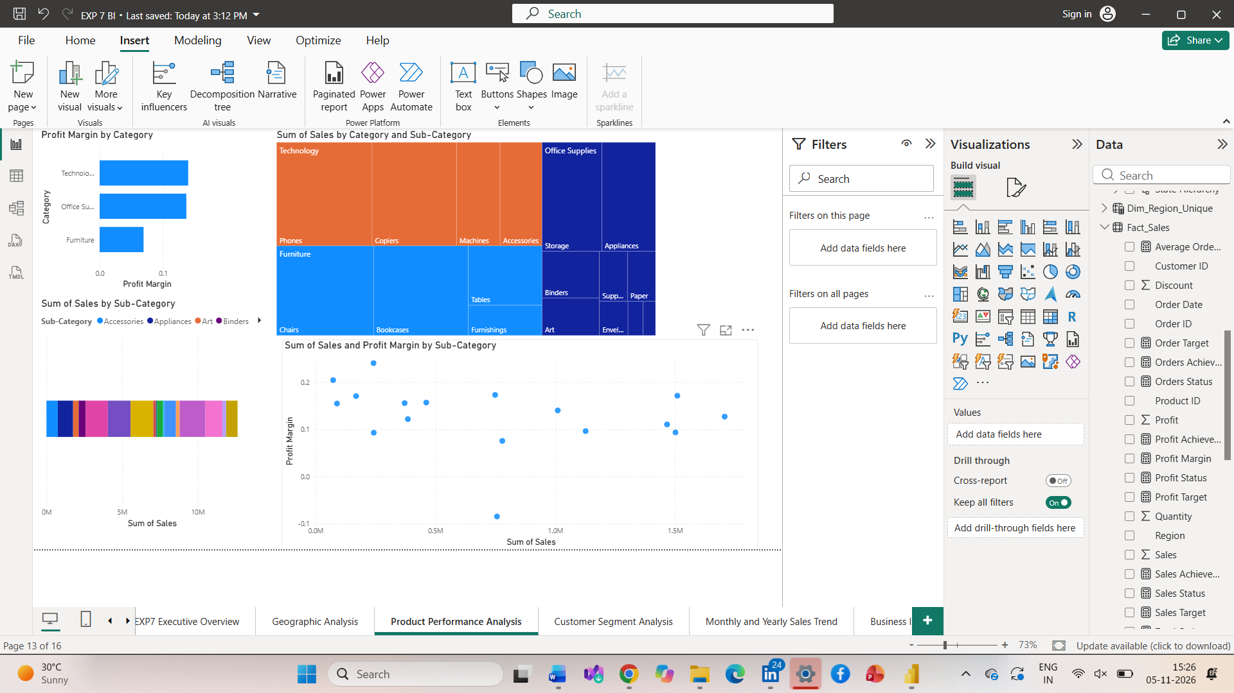
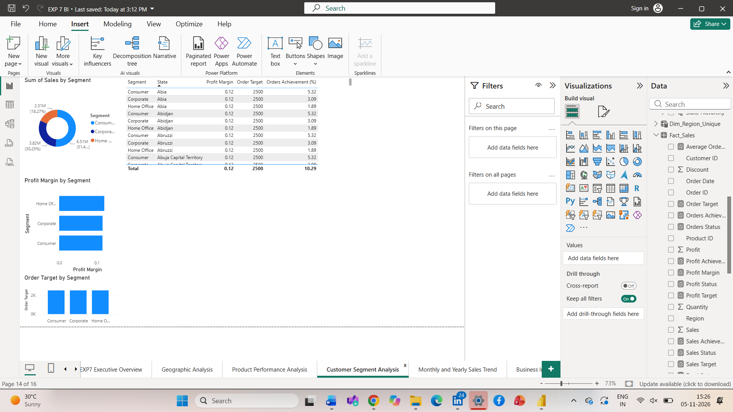
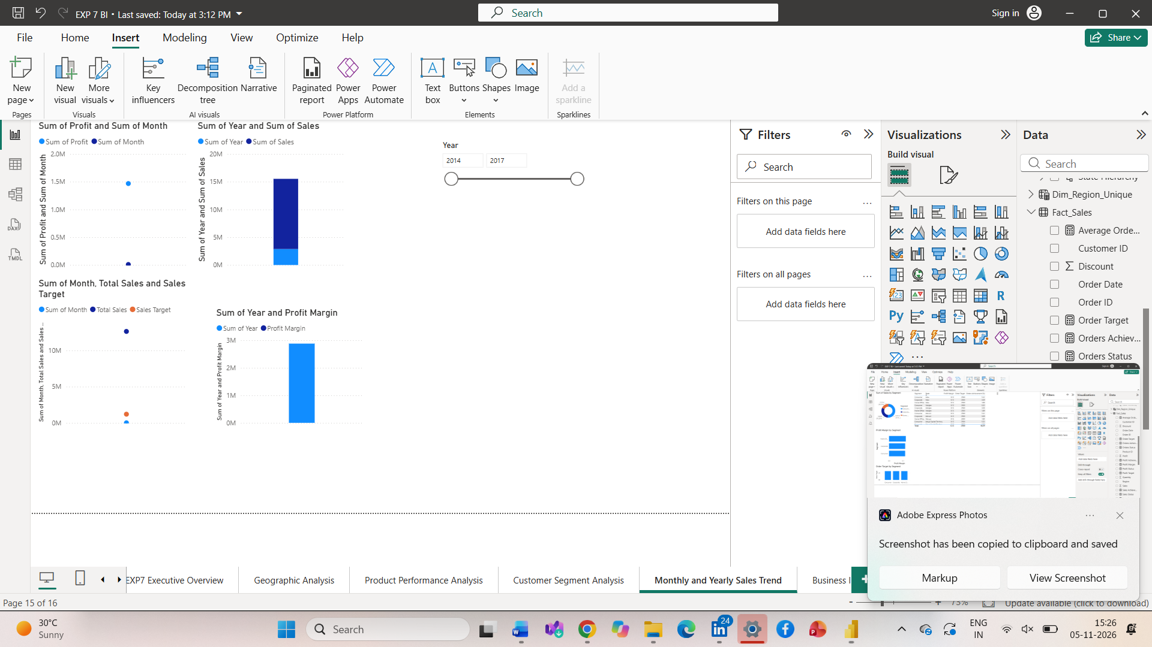
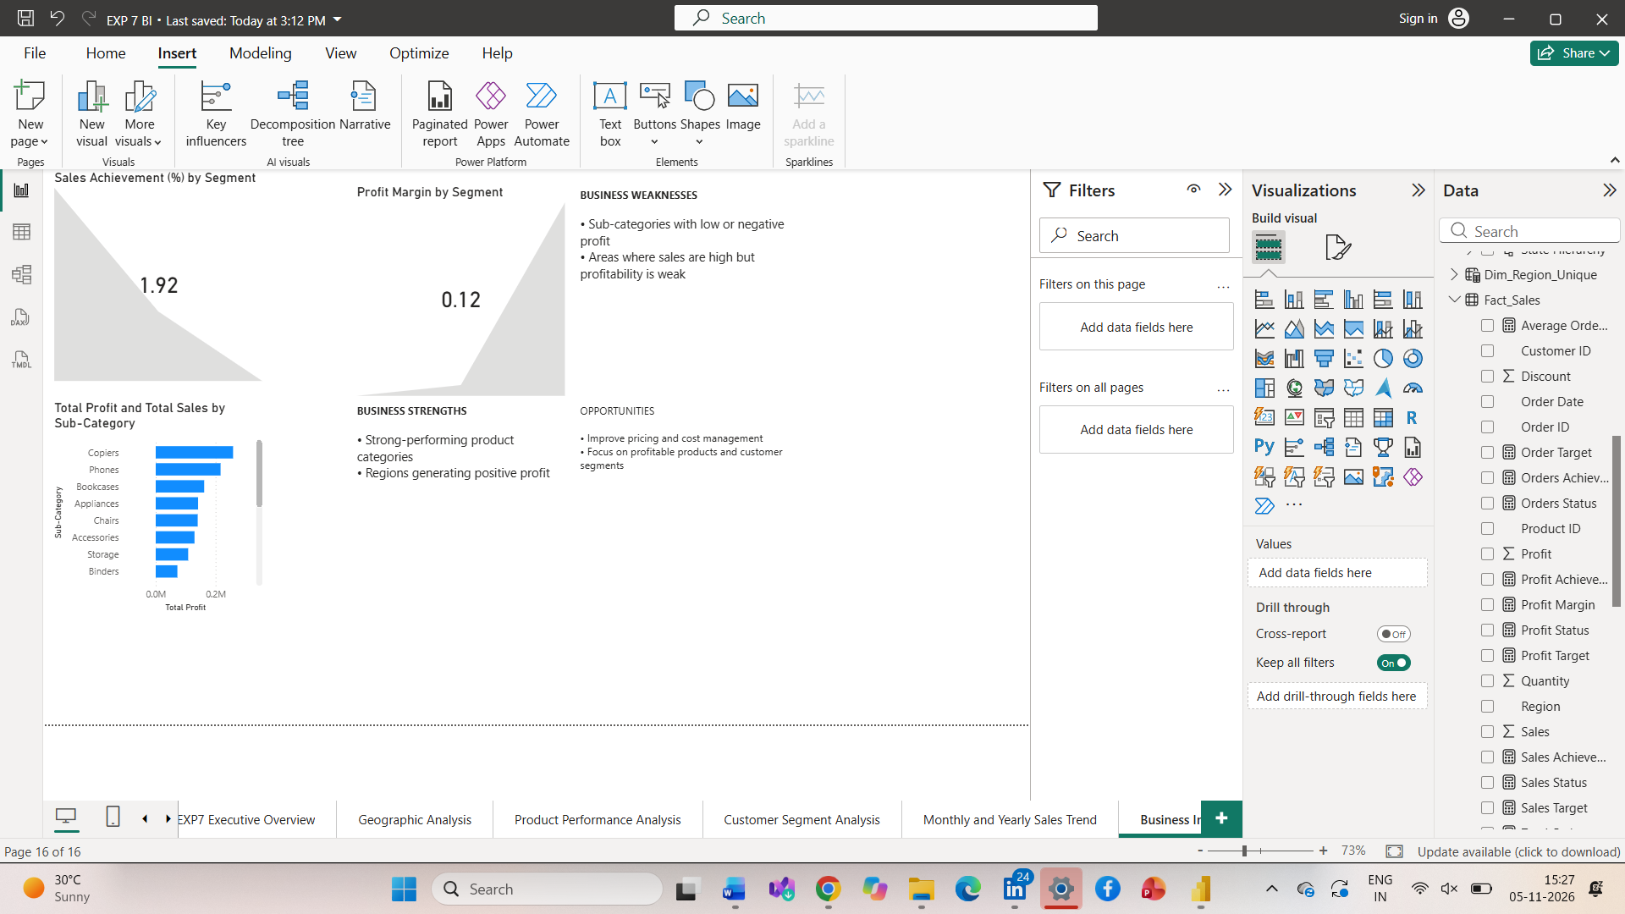
6. Observations
The integrated Power BI report provides different perspectives of organizational performance through relational reports, multidimensional analysis, interactive dashboards and business scorecards.
The regional analysis helps compare geographical sales and profitability. Product analysis identifies categories and sub-categories contributing to business profit. Customer segment analysis provides information about customer performance, while time-based analysis helps identify changes in sales and profitability.
The scorecard enables comparison of actual business performance against predefined targets. The advanced analytics report supports the identification of business strengths, weaknesses and opportunities for improvement.
7. Business Recommendations
Based on the analytical framework and the findings obtained from the Power BI reports, the following recommendations can be considered:
- Strengthen marketing and distribution activities in regions generating strong sales and profitability.
- Investigate the causes of lower performance in weaker geographical areas.
- Promote product categories and sub-categories that generate higher profits.
- Review pricing, discounting and operational costs for less profitable products.
- Improve customer engagement in promising customer segments.
- Monitor Sales Growth, Profit Margin and other KPIs regularly.
- Use the Business Scorecard to evaluate performance against organizational targets.
8. Result
An integrated Business Intelligence report was developed using Microsoft Power BI by combining data preparation, relational and multidimensional reporting, OLAP operations, comparative analysis, interactive dashboard development, executive dashboard creation, KPI-based scorecard development and advanced analytics.
Geographic, product, customer and time-based analyses were incorporated to evaluate organizational performance. The report provides a structured approach to identifying business strengths, weaknesses and opportunities and preparing data-driven recommendations for organizational decision-making.
9. Learning Outcomes
- Develop interactive dashboards and business scorecards using Microsoft Power BI.
- Apply OLAP operations to analyze business data at different levels.
- Apply advanced analytical techniques to business reports and dashboards. (CO3-BT3)
- Analyze organizational performance using BI tools and KPIs. (CO3-BT4)
- Generate business insights from analytical findings. (CO5-BT6)
- Develop strategic recommendations based on data-driven evidence. (CO5-BT6)
- Communicate analytical findings through professional reports and presentations. (CO5-BT6)
10. References
- Sharda, R., Delen, D. and Turban, E., Business Intelligence and Analytics.
- Howson, C., Successful Business Intelligence.
- Kimball, R. and Ross, M., The Data Warehouse Toolkit.
- Microsoft Power BI Documentation: https://learn.microsoft.com/power-bi/
- Global Superstore Dataset, Kaggle: https://www.kaggle.com/datasets/apoorvaappz/global-super-store-dataset

